410000 Bathroom Tissue - 500 Sheets - 2 Ply - 96 Rolls
 | 
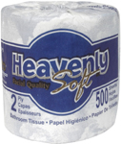 | Product Description: Bathroom Tissue - 500 Sheets - 2 Ply  Product #: 410000  Sheets/Roll: 500  Ply: 2 Ply  Sheet Size: 4.5" x 3.5"  Case Pack: 96 rolls  Cases per Pallet: 25  Case Cube: 5.07  Case Weight #: 35.04  Case Bar Code: 10613796112309  Case Dimensions: 26-5/16" x 17-3/4" x 18-3/4"

410001 Bathroom Tissue - 500 Sheets - 2 Ply - 96 Rolls
Product Description: Bathroom Tissue - 500 Sheets - 4.1" x 3.5" - 2 Ply
Product #: 410001
Sheets/Roll: 500
Ply: 2 Ply
Sheet Size: 4.1" x 3.5"
Case Pack: 96 rolls
Cases per Pallet: 25
Case Cube: 4.73
Case Weight #: 32.21
Case Bar Code: 10613796112323
Case Dimensions: 26-5/16" x 17-3/4" x 17-1/2"

410002 Bathroom Tissue - 1000 Sheets - 1 Ply - 96 Rolls
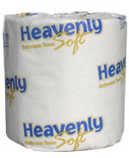 | Product Description: Bathroom Tissue - 1000 Sheets - 4.1" x 3.5" - 1 Ply  Product #: 410002  Sheets/Roll: 1000  Ply: 1 Ply  Sheet Size: 4.1" x 3.5"  Case Pack: 96 rolls  Cases per Pallet: 25  Case Cube: 4.73  Case Weight #: 35.88  Case Bar Code: 10613796112337  Case Dimensions: 26-5/16" x 17-3/4" x 17-1/2"

410021 Bathroom Tissue 4 Pack - 176 Sheets - 2 Ply
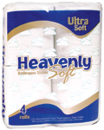 | Product Description: Bathroom Tissue 4 Pack – 176 Sheets - 4.1" x 4.0" - 2 Ply  Product #: 410021  Sheets/Roll: 176  Ply: 2 Ply  Sheet Size: 4.1" x 4.0"  Case Pack: 24/4  Cases per Pallet: 30  Case Cube: 3.51  Case Weight #: 16.36  Case Bar Code: 10613796122305  Case Dimensions: 23" x 15-1/2" x 17"

410035 Jumbo Roll Tissue 1000" - 2 Ply - 12 Rolls
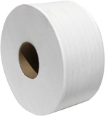 | Product Description: Jumbo Roll Tissue - 1000" x 3.5" - 2 Ply  Product #: 410035  Ply: 2 Ply  Sheet Size: 1000" x 3.5"  Core Size: 3.39"  Rolls Diameter: 9"  Case Pack: 12 Rolls  Cases per Pallet: 65  Case Cube: 2.21  Case Weight #: 22.86  Case Bar Code: 00613796132307  Case Dimensions: 27-1/2" x 18-1/2" x 7-1/2"

410041 Jumbo Roll Tissue 1000' - 2 Ply - 12 Rolls
Product Description: Jumbo Roll Tissue - 1000' x 3.5" - 2 Ply
Product #: 410041
Ply: 2 Ply
Sheet Size: 1000' x 3.5"
Core Size: 2.37"
Rolls Diameter: 9"
Case Pack: 12 Rolls
Cases per Pallet: 65
Case Cube: 2.21
Case Weight #: 23.71
Case Bar Code: 00613796132413
Case Dimensions: 27.5" x 18.5" x 25"

410042 Jumbo Roll Tissue 1125' - 2 Ply - 12 Rolls
Product Description: Jumbo Roll Tissue - 1125' x 3.5" - 2 Ply
Product #: 410042
Ply: 2 Ply
Sheet Size: 1125' x 3.5"
Rolls Diameter: 9"
Case Pack: 12 Rolls
Cases per Pallet: 65
Case Cube: 2.21
Case Weight #: 26.42
Case Bar Code: 00613796132420
Case Dimensions: 27.5" x 18.5" x 7.5"

410046 Roll Tissue - 616 Sheets - 2 Ply - 48 Rolls
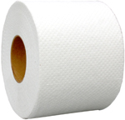 | Product Description: Roll Tissue - 616 Sheets - 2 Ply  Product #: 410046  Ply: 2 Ply  Sheets per Roll: 616  Core Size: 2.00"  Rolls Diameter: 4"  Case Pack: 48 Rolls  Cases per Pallet: 36  Case Cube: 2.85  Case Weight #: 19.83  Case Bar Code: 00613796133755  Case Dimensions: 20.5" x 15.5" x 15.5"

410073 Center Pull Towel - 600 Towels White - 2 Ply - 6 Rolls
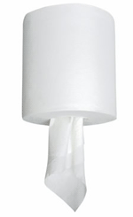 | Product Description: Center Pull Towel – 600 Towels – 2 Ply  Product #: 410073  Towels per Roll: 600  Core Size: 2.91"  Towel Size: 12"  Roll Width: 7.6"  Ply: 2 Ply  Rolls per Case: 6  Cases per Pallet: 60  Case Cube: 1.90  Case Weight #: 21.13  Case Bar Code: 00613796312334  Case Dimensions: 24.5" x 16.5" x 8.63"

410095 Hardwound Roll Towel 350' - Natural - 12 Rolls
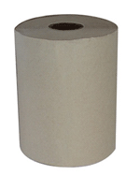 | Product Description: Hardwound Roll Towel - Natural - 350'  Product #: 410095  Feet per Roll: 350'  Roll Width: 8"  Ply: 1 Ply  Core Size: 2"  Case Pack: 12 Rolls  Cases per Pallet: 66  Case Cube: 1.93  Case Weight #: 23.28  Case Bar Code: 00613796412300  Case Dimensions: 22-3/4" x 17-1/2" x 8-3/8"

410096 Hardwound Roll Towel 350' - White - 12 Rolls
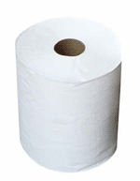 | Product Description: Hardwound Roll Towel - White - 350'  Product #: 410096  Feet per Roll: 350'  Roll Width: 8"  Ply: 1 Ply  Core Size: 2"  Case Pack: 12 Rolls  Cases per Pallet: 66  Case Cube: 1.93  Case Weight #: 23.28  Case Bar Code: 00613796412317  Case Dimensions: 22-3/4" x 17-1/2" x 8-3/8"

410101 Hardwound Roll Towel 800' - Natural - 6 Rolls
Product Description: Hardwound Roll Towel - Natural - 800'
Product #: 410101
Feet per Roll: 800'
Roll Width: 8"
Ply: 1 Ply
Core Size: 2"
Case Pack: 6 Rolls
Cases per Pallet: 55
Case Cube: 1.96
Case Weight #: 25.84
Case Bar Code: 00613796412362
Case Dimensions: 24-1/2" x 16-1/2" x 8-3/8"

410102 Hardwound Roll Towel 800' - White - 6 Rolls
Product Description: Hardwound Roll Towel - White - 800'
Product #: 410102
Feet per Roll: 800'
Roll Width: 8"
Ply: 1 Ply
Core Size: 2"
Case Pack: 6 Rolls
Cases per Pallet: 55
Case Cube: 1.96
Case Weight #: 25.84
Case Bar Code: 00613796412379
Case Dimensions: 24-1/2" x 16-1/2" x 8-3/8"

410163 Multifold Towel - Natural - 1 Ply - 4000
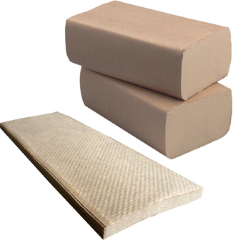 | Product Description: Multifold Towel - Natural - 16 x 250/Pack - 1 Ply  Product #: 410163  Package: 16 x 250/Pack  Towel Size: 9.25" x 9.5"  Ply: 1  Towels per Case: 4000  Cases per Pallet: 70  Case Cube: 1.56  Case Weight #: 18.22  Case Bar Code: 00613796612304  Case Dimensions: 21" x 13-1/8" x 9-3/4"

410164 Multifold Towel - White - 1 Ply - 4000
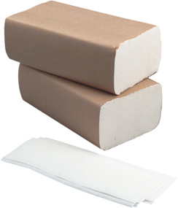 | Product Description: Multifold Towel - White - 16 x 250/Pack - 1 Ply  Product #: 410164  Package: 16 x 250/Pack  Towel Size: 9.25" x 9.5"  Ply: 1  Towels per Case: 4000  Cases per Pallet: 70  Case Cube: 1.56  Case Weight #: 19.85  Case Bar Code: 00613796612311  Case Dimensions: 21" x 13-1/8" x 9-3/4"

410186 C-Fold Towel - White - 1 Ply
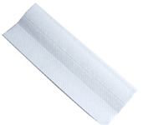 | Product Description: C-Fold Towel - White - 16 x 150/Pack - 1 Ply  Product #: 410186  Package: 16 x 150/Pack  Towel Size: 12" x 10"  Ply: 1  Towels per Case: 2400  Cases per Pallet: 81  Case Cube: 1.50  Case Weight #: 17.5  Case Bar Code: 0061379662319  Case Dimensions: 14"-7/8 x 10-7/8" x 16"

410189 Dinner Napkin 1/8 Fold - White - 2 Ply
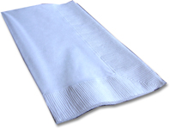 | Product Description: Dinner Napkin 1/8 Fold - White - 2 Ply  Product #: 410189  Sheet Size: 15" x 17"  Ply: 2  Napkins per Case: 3000  Cases per Pallet: 24  Case Cube: 2.82  Case Weight #: 15.00  Case Bar Code: 10613796712308  Product Bar Code: 613796712301  Case Dimensions: 17-5/16" x 15-7/8" x 18-1/2"

